**Laporan 8 – Hasil Prediksi M1 dan M4**

**M1 – Implementasi SB-LSTM-RNN tanpa iklim dan ENSO**

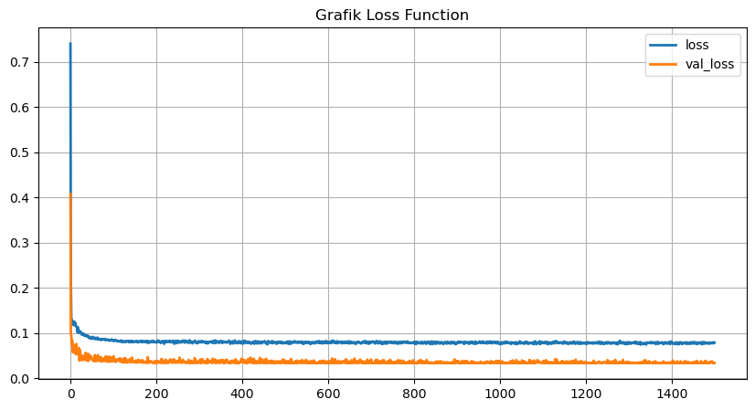

Gambar 1. Grafik loss function M1

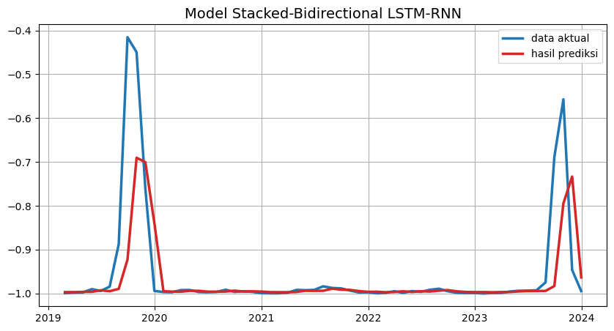

Gambar 2. Hasil prediksi titik panas M1

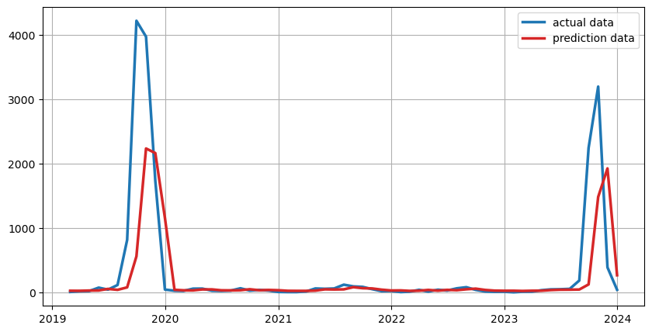

Gambar 3. Hasil prediksi titik panas M1

**M4 – Implementasi SB-GRU-RNN tanpa iklim dan ENSO**

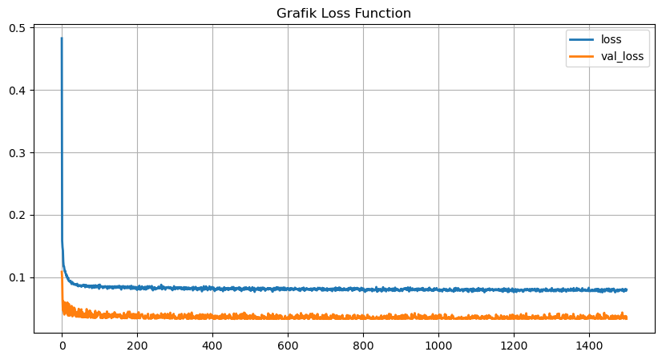

Gambar 4. Grafik loss function M4

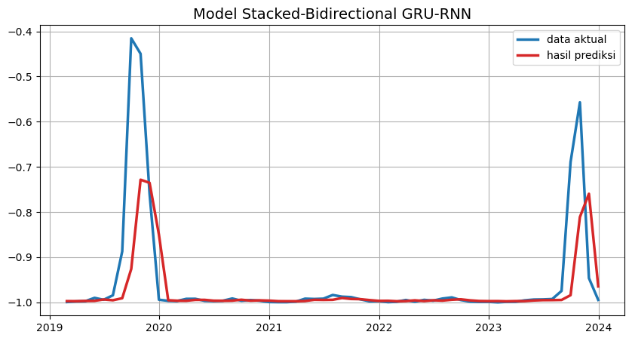

Gambar 5. Hasil prediksi titik panas M4

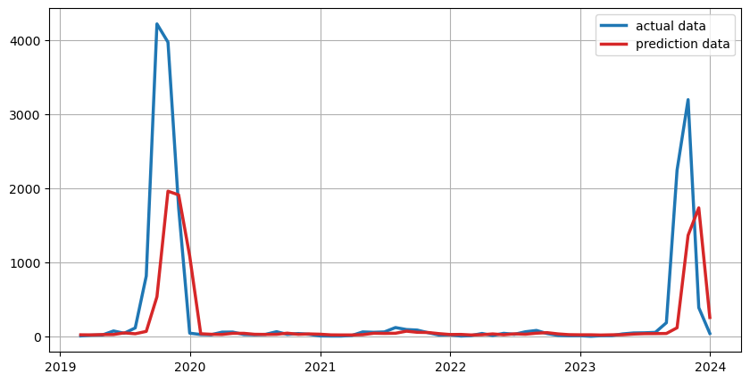

Gambar 6. Hasil prediksi titik panas M4

|  |  |  |  |
| --- | --- | --- | --- |
| Date | Data Aktual | Data Prediksi M1 | Data Prediksi M4 |
| 28/02/2019 | 8 | 26 | 23 |
| 31/03/2019 | 18 | 26 | 22 |
| 30/04/2019 | 21 | 30 | 26 |
| 31/05/2019 | 75 | 31 | 27 |
| 30/06/2019 | 44 | 55 | 49 |
| 31/07/2019 | 116 | 41 | 37 |
| 31/08/2019 | 817 | 79 | 69 |
| 30/09/2019 | 4223 | 562 | 537 |
| 31/10/2019 | 3976 | 2238 | 1963 |
| 30/11/2019 | 1736 | 2167 | 1913 |
| 31/12/2019 | 45 | 1161 | 1087 |
| 31/01/2020 | 27 | 41 | 37 |
| 29/02/2020 | 24 | 34 | 30 |
| 31/03/2020 | 59 | 32 | 28 |
| 30/04/2020 | 60 | 47 | 43 |
| 31/05/2020 | 27 | 47 | 43 |
| 30/06/2020 | 24 | 34 | 30 |
| 31/07/2020 | 29 | 32 | 28 |
| 31/08/2020 | 65 | 34 | 30 |
| 30/09/2020 | 29 | 50 | 45 |
| 31/10/2020 | 40 | 34 | 30 |
| 30/11/2020 | 30 | 39 | 35 |
| 31/12/2020 | 8 | 35 | 31 |
| 31/01/2021 | 6 | 26 | 22 |
| 28/02/2021 | 6 | 25 | 21 |
| 31/03/2021 | 15 | 25 | 21 |
| 30/04/2021 | 62 | 28 | 25 |
| 31/05/2021 | 57 | 48 | 44 |
| 30/06/2021 | 62 | 46 | 42 |
| 31/07/2021 | 121 | 48 | 44 |
| 31/08/2021 | 94 | 82 | 72 |
| 30/09/2021 | 87 | 66 | 57 |
| 31/10/2021 | 51 | 62 | 54 |
| 30/11/2021 | 20 | 44 | 39 |
| 31/12/2021 | 23 | 31 | 27 |
| 31/01/2022 | 6 | 32 | 28 |
| 28/02/2022 | 12 | 25 | 21 |
| 31/03/2022 | 41 | 27 | 24 |
| 30/04/2022 | 14 | 39 | 35 |
| 31/05/2022 | 43 | 28 | 24 |
| 30/06/2022 | 30 | 40 | 36 |
| 31/07/2022 | 64 | 35 | 31 |
| 31/08/2022 | 82 | 49 | 45 |
| 30/09/2022 | 40 | 59 | 52 |
| 31/10/2022 | 15 | 39 | 35 |
| 30/11/2022 | 10 | 28 | 25 |
| 31/12/2022 | 11 | 26 | 23 |
| 31/01/2023 | 3 | 27 | 23 |
| 28/02/2023 | 11 | 23 | 20 |
| 31/03/2023 | 12 | 27 | 23 |
| 30/04/2023 | 35 | 27 | 24 |
| 31/05/2023 | 48 | 37 | 33 |
| 30/06/2023 | 50 | 42 | 38 |
| 31/07/2023 | 56 | 43 | 39 |
| 31/08/2023 | 186 | 46 | 41 |
| 30/09/2023 | 2247 | 125 | 118 |
| 31/10/2023 | 3200 | 1485 | 1367 |
| 30/11/2023 | 390 | 1928 | 1738 |
| 31/12/2023 | 42 | 267 | 257 |

**Evaluasi Model Prediksi**

|  |  |  |  |  |  |  |  |  |  |  |
| --- | --- | --- | --- | --- | --- | --- | --- | --- | --- | --- |
| Model | Paramater Tuning NN | | | | Evaluasi Model | | | | | |
| 1 | 2 | 3 | 4 | MAE | MSE | MPE | R | R2 | P-value |
| M1 | SeLU | SGD | 0,15 | 8 | 3.373 | 0.921 | 5.710 | 0.648 | 0,419 | 0,000 |
| M4 | SeLU | SGD | 0,25 | 4 | 3.346 | 0.9477 | 5.77 | 0.6509 | 0,422 | 0,000 |

Note

1 = Activation function

2 = Optimizers

3 = Droupout

4 = Batch Size